# Section 9 Assignment (108 POINTS) – Boolean Functions

To receive credit, you must either show your work on the worksheet or explain how you got the answer.

1. (12 points) Draw the arrow diagram and the matrix representation for each relation.
   1. (6 pts) The domain for relation R is {1, 2, 3, 4}

R = { (1, 2), (1, 4), (2, 2), (2, 1), (4, 1), (4, 2), (4, 3), (4, 4)}

1

2

3

4

1

2

3

4

1 2 3 4

1 0 1 0 1

2 1 1 0 0

3 0 0 0 0

4 1 1 1 1

* 1. (6 pts) The domain of relation P is {1, 2, 3, 4, 5}

For x, y in the domain, xPy if $⌈\frac{x}{y}⌉>1$

R = {(2,1),(3,1),(3,2),(4,1),(4,2),(4,3),(5,1),(5,2),(5,3),(5,4)}

1

2

3

4

5

1

2

3

4

5

1 2 3 4 5

1 0 0 0 0 0

2 1 0 0 0 0

3 1 1 0 0 0

4 1 1 1 0 0

5 1 1 1 1 0

1. (18 points) For each relation, indicate whether the relation is:

* reflexive, anti-reflexive, neither,
* symmetric, anti-symmetric, neither, both
* transitive or not transitive

|  |  |  |  |  |
| --- | --- | --- | --- | --- |
|  | 1 | 2 | 3 | 4 |
| 1 | 0 | 1 | 1 | 1 |
| 2 | 1 | 1 | 0 | 0 |
| 3 | 0 | 0 | 1 | 0 |
| 4 | 1 | 0 | 1 | 1 |

1. (6 pts)

neither, anti-symetric, not transitive

1. (6 pts)

|  |  |  |  |  |
| --- | --- | --- | --- | --- |
|  | 1 | 2 | 3 | 4 |
| 1 | 1 | 1 | 0 | 1 |
| 2 | 1 | 1 | 0 | 0 |
| 3 | 0 | 0 | 1 | 1 |
| 4 | 1 | 0 | 1 | 1 |

reflexive, both, not transitive

|  |  |  |  |  |
| --- | --- | --- | --- | --- |
|  | 1 | 2 | 3 | 4 |
| 1 | 1 | 0 | 0 | 0 |
| 2 | 0 | 1 | 0 | 0 |
| 3 | 0 | 0 | 1 | 0 |
| 4 | 0 | 0 | 0 | 1 |

1. (6 pts)

reflexsive, symmetric, transitive

1. (6 points) Determine whether the relation R on the set A is an equivalence relation

A = {a, b, c}, R = { (a, a), (a, c), (b, b), (c, a), (c, c)}

**no because it is not transitive**

1. (10 points) Figure 1 shows a directed graph (digraph).

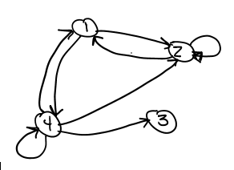

Figure 1

* 1. (2 pts) What is the in-degree of vertex 4?

2

* 1. (2 pts) What is the out-degree of vertex 4?

4

* 1. (2 pts) What is the head of edge (4, 3)?

3

* 1. (2 pts) What is the tail of edge (4, 2)?

4

* 1. (2 pts) List all self-loops in the graph, if any:

**(4,4), (2,2)**

**zyBook defines a path as a succession of edges and vertices with no repeating edge or vertex. (Section 9.3). The textbook indicates the vertices <and the edges for that matter> don't have to be distinct. (Chapter 4.3).**

**Question 5 and 6 uses the zyBook definition:**

1. (6 points) WALK/TRAIL/PATH in Figure 1
   1. (3 pts)

Is ⟨1, 2, 4, 1⟩ a walk in the graph? no

Is it a trail? no

Is it a path? **no**

Figure 1

* 1. (3 pts)

Is ⟨4, 2, 2, 1⟩ a walk in the graph? yes

Is it a trail? yes

Is it a path? no



1. (6 points) CIRCUIT/CYCLE in Figure 1
   1. (2 pts)

Is ⟨2, 1, 4, 2⟩ a circuit in the graph? yes

Is it a cycle? yes

* 1. (2 pts)

Is ⟨2, 1, 2, 1, 2, 1⟩ a circuit in the graph? no

Figure 1

Is it a cycle? no

* 1. (2 pts)

Is ⟨4, 4, 2, 2, 1, 4⟩ a circuit in the graph? yes

Is it a cycle? no

1. (20 points) Figure 2 shows a graph G. Draw G2, G3, and G4. Then take the union of all of the graphs (including G) to get G+

G^2 G^3

1

2

4

3

1

2

4

3

Figure 2

G^4 G^+

2

1

2

1

4

4

3

3

**zyBook defines a path as a succession of edges and vertices with no repeating edge or vertex. (Section 9.3). The textbook indicates the vertices <and the edges for that matter> don't have to be distinct. (Chapter 4.3).**

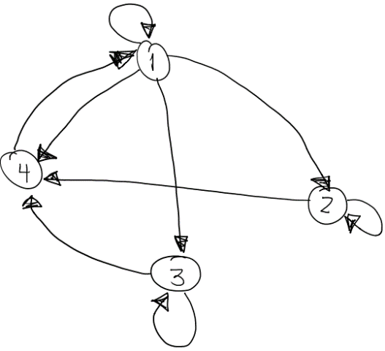

Figure 5

1. (10 points) For the digraph in Figure 5,



* 1. (5 pts) List all TEXTBOOK paths of length 3 starting from vertex 2

2,2,2,2 2,2,2,4 2,2,4,1 2,4,1,1



2,4,1,4 2,4,1,2 2,4,1,3

* 1. (5 pts) List all ZYBOOK paths of length 3 starting from vertex 2

2,4,1,3

|  |  |  |  |
| --- | --- | --- | --- |
| A = | 3 | 3 | 1 |
|  | 6 | -2 | 0 |

|  |  |  |  |
| --- | --- | --- | --- |
|  | 2 | 2 | -1 |
| B = | 8 | 7 | 3 |
|  | 4 | -1 | 4 |

For question 9 let…

|  |  |  |  |
| --- | --- | --- | --- |
|  | 1 | 1 | 0 |
| C = | -3 | 2 | 2 |
|  | 6 | 5 | 1 |

|  |  |  |  |
| --- | --- | --- | --- |
|  | 9 |  | 2 |
| D = | 5 |  | 4 |

1. (20 points) If possible, compute each of the following:
   1. (4 pts) B + C



|  |  |  |
| --- | --- | --- |
| 3 | 3 | -1 |
| 5 | 9 | 5 |
| 10 | 4 | 5 |

* 1. (6 pts) BA

Not possible

* 1. (8 pts) AD

not possible